Exception Handle Manual
Assets Management System
Author: Geoffrey Zhao
Last Updated: Geoffrey Zhao03/12/14

Executive Summary
This document specifies the exception handle situation of Augmentum internal Assets Management System. It is used for user to know the situation that when the system exception occurs.

- System Level Exception
In AMS, system level exception mainly contains three types:
a. 404 error – url is not existed,
b. 500 error – backend server error,
c. authority error - user authority error.

There are three error pages correspond them: error_404.jsp, error_500.jsp, authorityError.jsp. The following is 404 error page:

When user visit a non-existent url, the system will redirect the 404 error page.
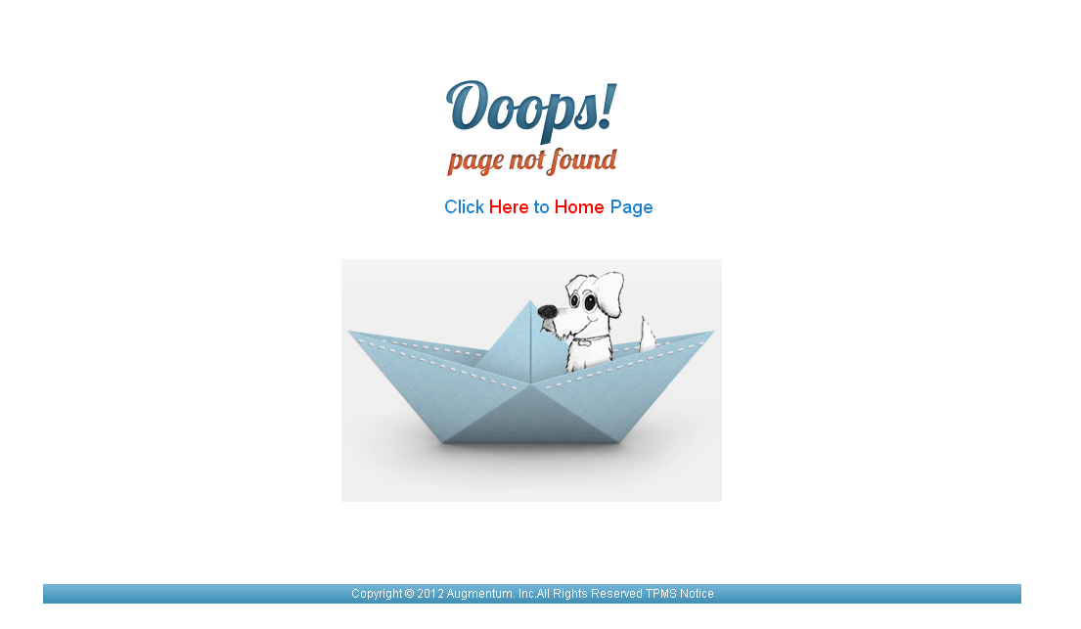
User can click “Here” or “Home ” to visit index page – dashboard page.

- Business Exception:
1. In the backend, we validate and trow self_define exception in serviceImpl layer. And try catch them in controller layer. Here, the error information(contains self_define error message and exception stackTrace) we just record it in logger and user will not read it. When we try catch an exception, just throw an self_define error code and at last show user message tip with i18n. All the error code are defined in ErrorCodeUtil.java. The corresponding error message are defined in jqueryi18n_en.properties and jqueryi18n_zh.properties.

The following is partial error codes in jqueryi18n_en.properties:

0201001=Asset save failed!
0201002=Asset update failed!
0201003=Asset delete failed!
0201004=Asset is not existed!
0201005=Asset is existed!
0201006=Asset status is invalid!
0201007=Asset ownership is invalid!
0201008=Asset assign failed!
0201009=Asset return failed!
0201010=Asset take over failed!
0201011=Asset change to fixed failed!
0201012=Asset change to non-fixed failed!
0201013=Asset add to audit failed!
0201014=Format error! Import asset failed!
0201015=Export asset failed!

0201016=Asset name can not be empty
0201017=Asset type can not be empty
0201018=Asset entity can not be empty
0201019=Asset customer can not be empty
0201020=Asset site can not be empty
0201021=Asset name can not larger than 36 chars
0201022=Asset room can not be empty

The following is generally process about throw and handle exception:

AssetServiceImpl:

public void returnAssetsToCustomer(String assetIds) throws ExceptionHelper {

logger.info("enter returnAssetsToCustomer service successfully");
if (null == assetIds || "".equals(assetIds)) {
logger.error("The param assetIds is null when assets return to Customer");
throw new ExceptionHelper(ErrorCodeUtil.ASSET_RETURN_FAILED);
} else {

String[] assetIdArr = FormatUtil.splitString(assetIds, SystemConstants.SPLIT_COMMA);
Map<String, ExceptionHelper> errorCodes = new LinkedHashMap<String, ExceptionHelper>();

for (String id : assetIdArr) {
Asset asset = assetDao.getAssetById(id);

if (null == asset) {
logger.error("asset is null when return assets to customer, asset uuid: " + id);
errorCodes.put(id, new ExceptionHelper(ErrorCodeUtil.DATA_NOT_EXIST));
} else {
if (!AssetStatusOperateUtil.canITReturnToCustomer(asset)) {
logger.error("asset status is invalid when IT return assets to customer, asset uuid: "
+ id);
errorCodes.put(id, new ExceptionHelper(ErrorCodeUtil.ASSET_STATUS_INVALID));
} else {
asset.setStatus(StatusEnum.RETURNED.name());
asset.setUser(null);
assetDao.update(asset);
}
}
}
if (0 != errorCodes.size()) {
throw new ExceptionHelper(errorCodes);
}
logger.info("leave returnAssetsToCustomer service successfully");
}
}

AssetController:

@RequestMapping(value = "/returnAssetsToCustomer")
public ModelAndView returnAssetsToCustomer(String assetIds) {

ModelAndView modelAndView = new ModelAndView();

try {
assetService.returnAssetsToCustomer(assetIds);
} catch (ExceptionHelper e) {
modelAndView = this.addErrorCode(e);
}
transferLogService.saveTransferLog(assetIds, "ReturnToCustomer");
return modelAndView;
}

js:

$("#returnAssetsToCustomer").parent("li").click(function(){
if (checkActivedAssetIds() && checkActivedAssetsStatusForReturn()) {
ShowMsg(i18nProp('message_confirm_asset_returnToCustomer', $('.row .dataList-checkbox-active').size().toString()), function(yes){
if (yes) {
$("div .dataList-div-loader").show();
$.ajax({
type : 'GET',
contentType : 'application/json',
url : 'asset/returnAssetsToCustomer',
dataType : 'json',
data: {
assetIds: getActivedAssetIds()
},
success : function(data) {
criteria.pageNum = 1;
dataList.search();
if (data.errorCodes) {
showMessageBarForAssetList(data.errorCodes);
} else if (data.errorCode) {
showMessageBarForMessage(data.errorCode);
}
}
});
}else{
return;
}
});
}
});

The following is exception tip message when asset is not existed:

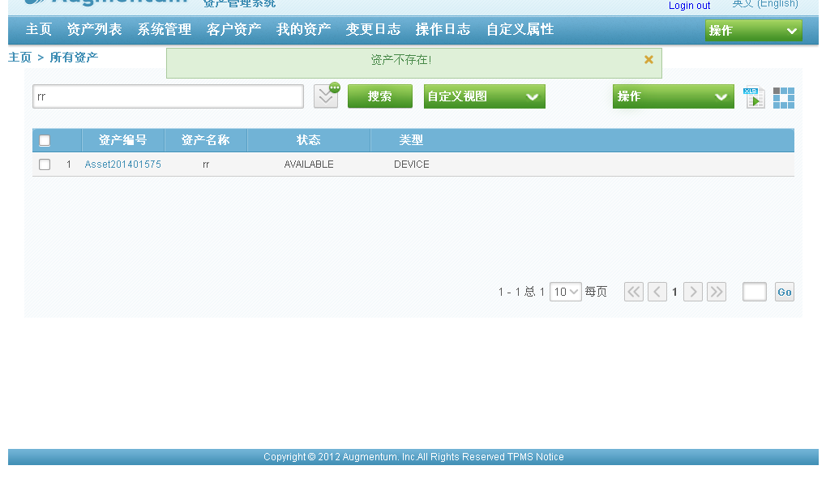

The partial backend log error and exception stackTrace information as following:

[2014-03-12 10:46:42,567 ERROR at com.augmentum.ams.service.asset.impl.AssetServiceImpl.returnAssetsToCustomer(AssetServiceImpl.java:580)] asset is null when return assets to customer, asset uuid: 4028961244aba0120144abbb73b0001c

at com.augmentum.ams.service.asset.impl.AssetServiceImpl.returnAssetsToCustomer(AssetServiceImpl.java:595)
at com.augmentum.ams.service.asset.impl.AssetServiceImpl$$FastClassByCGLIB$$85bd0783.invoke(<generated>)
at net.sf.cglib.proxy.MethodProxy.invoke(MethodProxy.java:191)
at org.springframework.aop.framework.Cglib2AopProxy$CglibMethodInvocation.invokeJoinpoint(Cglib2AopProxy.java:689)
at org.springframework.aop.framework.ReflectiveMethodInvocation.proceed(ReflectiveMethodInvocation.java:150)
at org.springframework.aop.framework.adapter.MethodBeforeAdviceInterceptor.invoke(MethodBeforeAdviceInterceptor.java:50)
at org.springframework.aop.framework.ReflectiveMethodInvocation.proceed(ReflectiveMethodInvocation.java:172)
at org.springframework.aop.aspectj.AspectJAfterThrowingAdvice.invoke(AspectJAfterThrowingAdvice.java:55)
at org.springframework.aop.framework.ReflectiveMethodInvocation.proceed(ReflectiveMethodInvocation.java:172)
at
...............

Exception tip message when asset status is invalid:
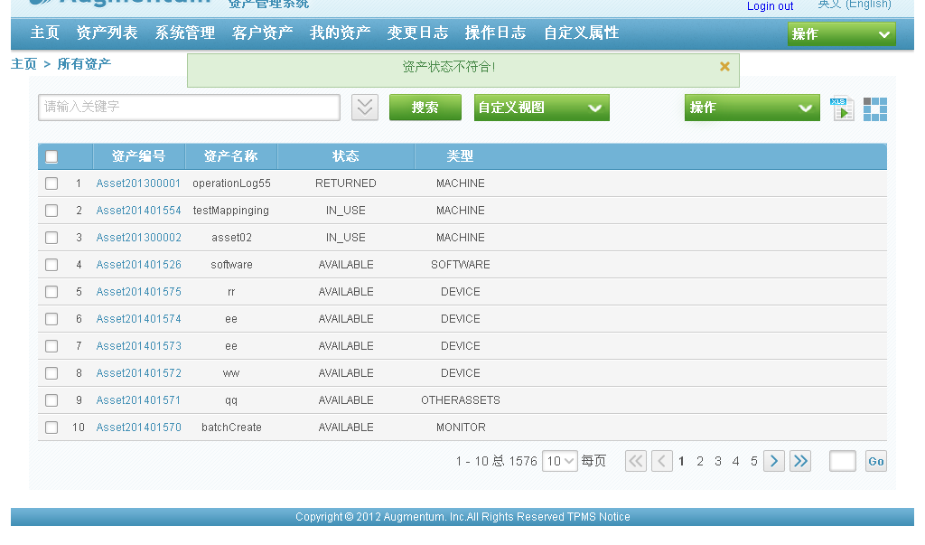

Backend error information:

ERROR at com.augmentum.ams.service.asset.impl.AssetServiceImpl.returnAssetsToCustomer(AssetServiceImpl.java:584)] asset status is invalid when IT return assets to customer, asset uuid: 4028961242e5d4d70142e5dc285500a4

com.augmentum.ams.util.ExceptionHelper
at com.augmentum.ams.service.asset.impl.AssetServiceImpl.returnAssetsToCustomer(AssetServiceImpl.java:595)
at com.augmentum.ams.service.asset.impl.AssetServiceImpl$$FastClassByCGLIB$$85bd0783.invoke(<generated>)
at net.sf.cglib.proxy.MethodProxy.invoke(MethodProxy.java:191)
at org.springframework.aop.framework.Cglib2AopProxy$CglibMethodInvocation.invokeJoinpoint(Cglib2AopProxy.java:689)
at org.springframework.aop.framework.ReflectiveMethodInvocation.proceed(ReflectiveMethodInvocation.java:150)
at org.springframework.aop.framework.adapter.MethodBeforeAdviceInterceptor.invoke(MethodBeforeAdviceInterceptor.java:50)
at org.springframework.aop.framework.ReflectiveMethodInvocation.proceed(ReflectiveMethodInvocation.java:172)
at org.springframework.aop.framework.adapter.AfterReturningAdviceInterceptor.invoke(AfterReturningAdviceInterceptor.java:50)
at org.springframework.aop.framework.ReflectiveMethodInvocation.proceed(ReflectiveMethodInvocation.java:172)

...........

Util method exception:

In util method, try catch the exception directly, NOT throw. And these error will not show in page. Just record it in log.

if (null != str && !"".equals(str)) {
SimpleDateFormat sdf = new SimpleDateFormat(pattern);

try {
date = sdf.parse(str);
} catch (ParseException e) {
logger.error("format string to date error", e);
return null;
}
}

Remote exception from IAP:

All the remote exception from IAP had been extracted in RemoteUtil.java

try {
responseBody = RequestHelper.sendRequest(request, requestBody, requestType);
} catch (ClientProtocolException e) {
throw new RemoteException(e, ErrorCodeUtil.DATA_IAP_0204001,
"Error from getting data from IAP!");
} catch (IOException e) {
throw new RemoteException(e, ErrorCodeUtil.DATA_IAP_0204001,
"Error from getting data from IAP!");
}
IAPDataResponseModel responseModel = IAPDataModelResponseUtil
.getResponseModel(responseBody);

if (responseModel.getStatus().getStatusCode() != 200
&& responseModel.getStatus().getStatusCode() != 201) {
throw new RemoteException(ErrorCodeUtil.DATA_IAP_0204001,
"Error from getting data from IAP!");
}

if (responseModel.getStatus().getStatusCode() == 201) {
logger.info("Get empty set from IAP!");
}

3. Exception Handle class

BusinessException:

public class BusinessException extends BaseException{
public BusinessException(Exception e, String errorcode) {
super(e, errorcode);
}

public BusinessException(String errorcode) {
super(errorcode);
}

public BusinessException(String errorCode, String errorMessage) {
super(errorCode, errorMessage);
}

public BusinessException(Exception e, String errorCode, String errorMessage) {
super(e,errorCode, errorMessage);
}

BaseException:

public class BaseException extends RuntimeException {
public BaseException(Exception e, String errorCode) {
this.errorCode = errorCode;
this.exception = e;
}

public BaseException(Exception e) {
this.exception = e;
}

public BaseException(String errorCode) {
this.errorCode = errorCode;
}

public BaseException(String errorCode, String errorMessage) {
this.errorCode = errorCode;
this.errorMessage = errorMessage;
}

public BaseException(Exception e, String errorCode, String errorMessage) {
this.exception = e;
this.errorCode = errorCode;
this.errorMessage = errorMessage;
}
}

4. Validation

AMS has two times validation: one time is javascript validation, the other one is spring validation annotation.

1. Generally we add validation annotation above VO properties. It used to validate input text, such as create asset. Spring validation annotation as following:

@NotBlank(message = ErrorCodeUtil.ASSET_NANE_VALIDATOR_FAILED)
@Size(max = 36, message = ErrorCodeUtil.ASSET_NANE_VALIDATOR_LENGTH_FAILED,
groups = GroupValidation.class)
private String assetName;

2. In most cases, we use javascript to validate. It contains two situations: one is to validate operation if valid. The other one is to validate input information if valid. The related effect as following:
a. no selected record when operation:

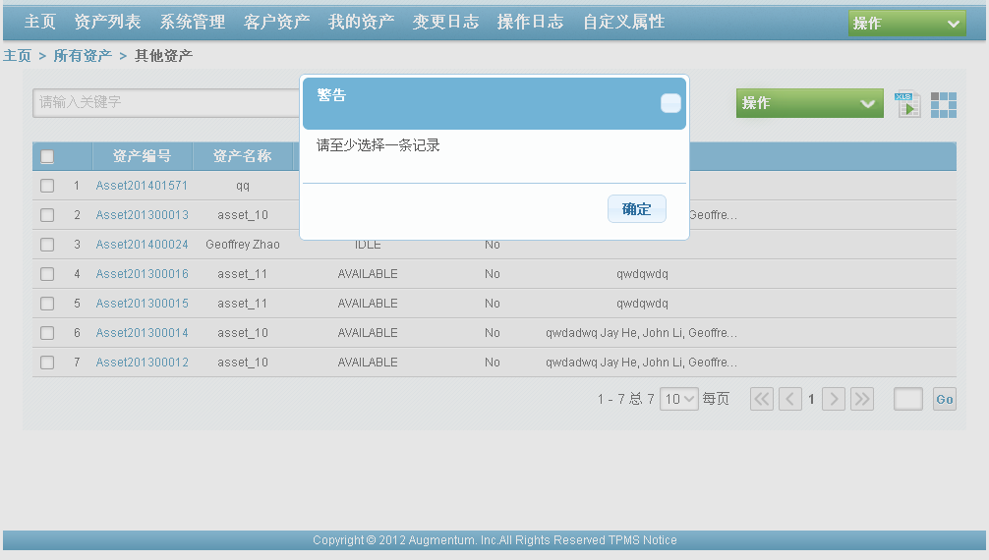

b. asset status is invalid when operation asset:

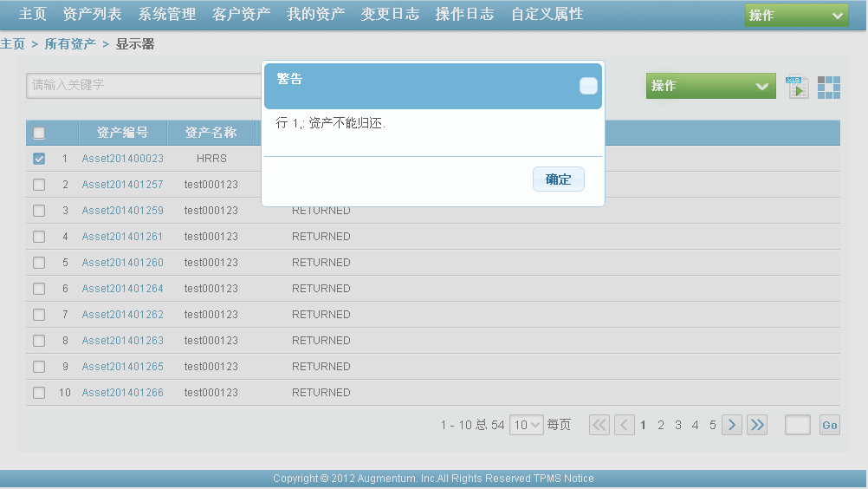

c. asset name is empty when create asset:

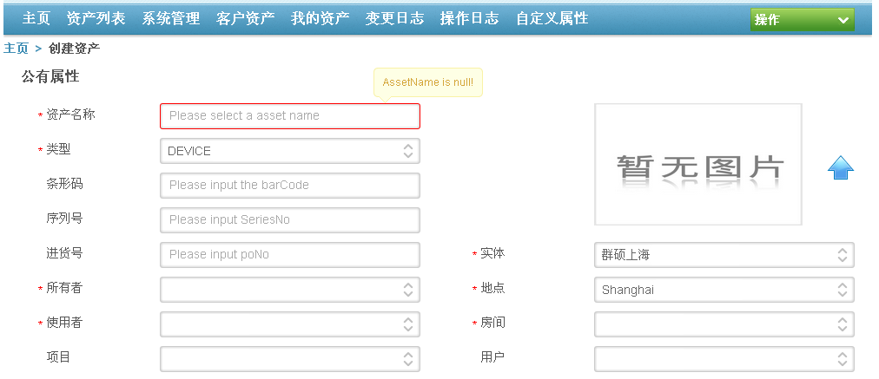

All the above tip message need to realize i18n, and the i18n information are defined in jqueryi18n_en.properties and jqueryi18n_zh.properties.

Note: In current AMS, validation is NOT overall. Some properties are not be validated and some properties are validated incorrectly. So the system need be tested overall then complete the necessary validation.

- Exception AOP

5.1 AOP to record the exception message

package com.augmentum.ams.aop.ExceptionAop

@Before(value = "execution(* com.augmentum.ams..*(..)) && !within(ExceptionAop)")
public void beforMethod(JoinPoint point) {

StringBuilder logInfo = getMethodAndParams(point);
logInfo.append(" Start...");

logger.info(logInfo);
}

@AfterReturning(value = "execution(* com.augmentum.ams..*(..)) && !within(ExceptionAop)")
public void afterMethod(JoinPoint point) {

logger.info(point.getSignature().getName() + "() End...");
}

beforMethod(JoinPoint point) and afterMethod(JoinPoint point) are called when at begin and end methods to be called in the system.

@AfterThrowing(value = "execution(* com.augmentum.ams..*(..)) && !within(ExceptionAop)", throwing = "e")
public void catchException(JoinPoint joinPoint, Exception e) {

setUserAndIP();

if ((e instanceof BaseException)) {
BaseException baseException = (BaseException) e;
logger.error("Error code: " + ((BaseException) e).getErrorCode()
+ ",\t Error message: " + baseException.getErrorMessage() + "\n"
+ "Origianl exception: " + baseException.getException().getStackTrace() + "\n"
+ baseException);
logger.error(e.getMessage(), e);
} else {
logger.error(e.getMessage(), e);
}

}

catchException(JoinPoint joinPoint, Exception e) is called when the system trows any exception, and records the detail information of the exception.

  - BaseController specifies the forward pages or the error message when the system throws a exception.

package com.augmentum.ams.web.controller.base.BaseController;

@ExceptionHandler({ ExcelException.class })
@ResponseBody
protected JSONObject handleExcelException(ExcelException e) {

JSONObject jSONObject = new JSONObject();
jSONObject.put("error", e.getErrorCode());

return jSONObject;
}

@ExceptionHandler({ AuthorityException.class })
@ResponseBody
protected ModelAndView handleAuthorityException(AuthorityException e) {

ModelAndView mv = new ModelAndView(SystemConstants.AUTHORITY_ERROR_PAGE);

return mv;
}

@ExceptionHandler({ RemoteException.class, DataAccessException.class, BusinessException.class,
Exception.class })
protected ModelAndView handleServerErrorException() {

ModelAndView mv = new ModelAndView(SystemConstants.SERVER_ERROR_PAGE);

return mv;
}

@ExceptionHandler({ ValidatorException.class })
@ResponseBody
protected JSONObject handleValidatorException(ValidatorException ve) {

JSONObject jSONObject = new JSONObject();
jSONObject.put("error", ve.getErrorCode().replaceAll(",", " ").trim());

return jSONObject;
}

“@ExceptionHandler({ Exception.class })” using the spring mvc exception handler to intercept the exception.

5.3 ShiroFilter to intercept the illegal URL.

applicationContext.xml

<bean id="shiroFilter" class="org.apache.shiro.spring.web.ShiroFilterFactoryBean">
<property name="securityManager" ref="securityManager"></property>
<property name="loginUrl" value="/error_404"></property>
<property name="unauthorizedUrl" value="/authorityError"></property>
<property name="filters">
<map>
<entry key="authc" value-ref="authorityFilter" />
</map>
</property>
<property name="filterChainDefinitions">
<value>
/error/error = anon
/css/**=anon
/js/**=anon
/images/**=anon
/**=authc
/asset/listAsset/** = authc,perms[Asset:view_all]
/asset/assignAsset/** = authc,perms[Asset:assign_asset]
/asset/checkInAsset/** = authc,perms[Asset:check_in_asset]
/asset/checkOutAsset/** = authc,perms[Asset:check_put_asset]
/asset/createAsset/** = authc,perms[Asset:create]
/asset/checkInventory/** = authc,perms[Asset:check_inventory]
- /asset/importAssets/** = authc,perms[Asset:import_asset]
- /transferLog/** = authc,perms[TransferLog:*]
- /operationLog/** = authc,perms[OperationLog:*]
- /user/** = authc,perms[User:*]
- /location/** = authc,perms[Location:*]
- /**=authc

</value>
</property>
</bean>

User can only visist the URL which has been on commission, but this configuration has not been finished yet. Only a part of them has been completed.

5.4 AssetManagementSystem exception logical

